# Lab: Policy Based Management

|  |
| --- |
| * This is an in-class lab, and due tonight. * Use the following naming convention: homework, underscore, last name, first initial, and extension (e.g., Lab_PBM_ImG.docx). * Do not copy any of the sample screenshots provided as illustrations. |

* (**Task1**) Show in a screenshot like above that **usp_MyPolicyTest** stored procedure is created successfully. Do your own work and do not copy the screenshot above.

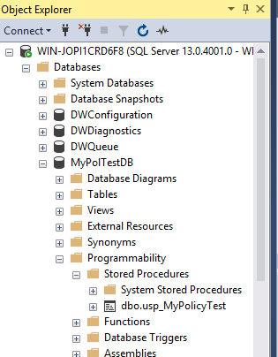

* (**Task2**) Show in a screenshot that **MyPolicyTest** stored procedure cannot be created. Capture the screen showing an error message.
* 